# VISVESVARAYA TECHNOLOGICAL UNIVERSITY

Jnana Sangama, Belagavi-590018



**A MINI PROJECT REPORT**

**ON**

***“*BINARY TO DECIMAL NUMBER CONVERTER APPLICATION*”***

***Submitted in the partial fulfilment of Sixth Semester Mini Project Work***

#### BACHELOR OF ENGINEERING IN

**COMPUTER SCIENCE AND ENGINEERING**

#### By

**HARI CHARAN K 1ME19CS037**

**ZIAUDDIN SYED 1ME19CS084**

#### Under the guidance of Mr.PANKAJ KUMAR

**Assistant Professor, CSE Dept.**

**MSEC, Bengaluru.**



## M S ENGINEERING COLLEGE

## DEPARTMENT OF COMPUTER SCIENCE & ENGINEERING

NAAC Accredited, Affiliated to VTU, Belagavi, Approved By AICTE New Delhi, Navarathna Agrahara, off Intl. Airport Road, Bengaluru– 562110

2021-2022

## M S ENGINEERING COLLEGE

## DEPARTMENT OF COMPUTER SCIENCE AND ENGINEERING



**CERTIFICATE**

This is to certify that the mini project work entitled **“BINARY TO DECIMAL NUMBER CONVERTER”** carried out by **HARI CHARAN K (1ME19CS037)** and **ZIAUDDIN SYED (1ME19CS084)** is a bonafide student of **M S ENGINEERING COLLEGE** submitted in partial fulfillment for the award of Bachelor of Engineeringin Computer Science and Engineeringof Visvesvaraya Technological University, Belagavi, during the year **2021-2022**. It is certified that all corrections/suggestions indicated for internal assessment have been incorporated in the report, deposited in the department library. This mini project work report has been approved as it satisfies the academic requirements in respect of mini project work prescribed for **Bachelor of Engineering** Degree.

**Signature of Guide Signature of HOD**

|  |  |  |
| --- | --- | --- |
| **Internal Examiner** | **Name** --------------------------- | **Signature** ------------------ |
| **External Examiner** | **Name** --------------------------- | **Signature** ------------------ |

**DATE:………………………..**

# ACKNOWLEDGEMENT

A mini project work of immense sheer size and it cannot be proficient by an individual all by them, ultimately We are gratifying to a number of individuals whose qualified guidance, and assistance and encouragement have made it a pleasant venture to undertake this project work.

We are grateful to our institution, **M S ENGINEERING COLLEGE** with its ideals and inspiration for having provided us with the facilities, which has made this mini project work a success.

We would like to express our gratitude to **Dr. K. S. BADARINARAYAN,** principal of MSEC who is the source of inspiration as well providing an amiable atmosphere to work in.

Further, We would like to express our kind gratitude towards, **Prof Dr. MALATESH S H**, HOD to Dept. of Computer Science Engineering and the whole department for providing us kindly environment for the successful completion of the mini project work.

We express our sincere gratitude to our internal guide **Mr. PANKAJ KUMAR Professor** in **Computer Science and Engineering Department** for giving us the valuable suggestions regarding the project

It’s our duty to thank one and all faculties of CSE Department, who have directly or indirectly supported to accomplish the project work successfully.

We would also like to thank my friends, who really helped us to complete this mini project work successfully.

HARI CHARAN K 1ME19CS037 ZIAUDDIN SYED 1ME19CS084

TABLE OF CONTENT

ACKNOWLEDGEMENT 3

ABSTRACT… 5

CHAPTER1 INTRODUCTION

* 1. INTRODUCTION 6
  2. SCOPE 6

CHAPTER 2 SYSTEM REQUIREMENTS SPECIFICATION

* 1. SYSTEM REQUIREMENTS 7
     1. SOFTWARE REQUIREMENTS 7

2.2.1 HARDWARE REQUIREMENTS 7

* 1. TOOLS AND TECHNOLOGIES USED
     1. ANDROID STUDIO 7
     2. ANDROID SOFTWARE DEVELOPMENT KIT (SDK) 7
     3. ANDROID DEBUG BRIDGE (ADB) 8
  2. PROJECT DEVELOP LANGUAGES 8

CHAPTER 3 SOURCE CODE

SOURCE CODE………………………………………………………………………….9-12

CHAPTER 4 SCREENSHOTS

SCREENSHOTS………………………………………………………………………..13-14

CHAPTER 5 CONCLUSION

CONCLUSION 15

CHAPTER 6 BIBILOGRAPHY

BIBLOGRAPHY 16

# ABSTRACT

Bits represent one of two values, 0 or 1, and are joined together to form binary numbers. Each column of a binary number has twice the weight of the previous column, so binary numbers are base 2. In binary, the column weights (again, from right to left) are 1, 2, 4, 8, 16, 32, 64, 128, 256, 512, 1024, 2048, 4096, 8192, 16384, 32768, 65536, and so on. If you work with binary numbers often, you’ll save time if you remember these powers of two up to 216.

An N-bit binary number represents one of 2N possibilities: 0, 1, 2, 3, …, 2N − 1. Table 1.1 shows 1-, 2-, 3-, and 4-bit binary numbers and their decimal equivalents.

We generally use the base10 (also known as decimal) numbering system, which uses 10 values (0, 1, 2, 3, 4, 5, 6, 7, 8, 9) to represent numbers.

Computers use the base2 (also known as binary) numbering system to represent data. The [binary numbering system](https://www.sciencedirect.com/topics/computer-science/binary-number-system) uses two values, 0 and 1, to represent numbers. This is because a computer only recognizes two states: the presence or absence of an electrical charge. Even if a computer is showing you decimal numbers, it is merely a translation of the binary numbers inside the machine.

# CHAPTER 1

## INTRODUCTION

* 1. **INTRODUCTION TO PROJECT**

Most of the computers can understand the binary numbers where humans can’t understand them y the use of this project we can easily convert the large binary numbers to the Decimal numbers where everyone can understand them easily. In commercial business and internet based applications, decimal arithmetic is receiving significant importance. Decimal arithmetic is important in many applications such as banking, tax calculation, insurance, accounting and many more. Even though binary arithmetic is used widely, decimal computation is essential. The decimal arithmetic is not only required when numbers are presented for inspection by humans, but also it is a necessity when fractions are being used. Rational numbers whose denominator is a power of ten are decimal fractions and most them cannot be represented by binary fractions. For example, the value 0.01 may require an infinitely recurring binary number. Even though the arithmetic is correct, but if binary approximation is used instead of an exact decimal fraction, results can be wrong.

## SCOPE

This extensive use of decimal data indicates that it is important to analyse how the data can be used and how the decimal arithmetic can be defined. However, the current general purpose computers perform decimal computations using binary arithmetic. But the problem is that decimal numbers such as 0.3 cannot be represented precisely in binary. The errors that result on conversion between decimal and binary formats cannot be tolerated as long as precision is concerned.

By the use of this application we can easily convert the Binary numbers to Decimal numbers where everyone can understand them easily.

# CHAPTER 2

**REQUIREMENTS AND SPECIFICATION**

# SYSTEM REQUIREMENTS:

#### Software Requirements:

* + - * Operating System – Windows.
      * Memory-8GB RAM
      * Free storage-8GB
      * Screen resolution-1280 x 800

#### Hardware Requirements:

* + - * Processor – At least 2.0 GHZ
      * RAM – 8GB or more

#### TOOLS AND TECHNOLOGIES USED:

#### Android Studio:

Android Studio [6] is exclusively designed for developing Android applications. It consists of all Android SDK tools to design, develop, maintain, test, debug and publish our app.

#### Android Software Development Kit(SDK):

One of the main tools used in developing android applications, as it packages many core features into one SDK and it can be used in the application easily. This helps us to avoid writing lot of code, and building applications faster.

# Android Debug Bridge (ADB);

Android SDK uses ADB tool as a connection device which allows us to connect the Android Devices or Emulator with the machine via USB. After developing or while developing applications, we can connect with the device to check how the application runs. Later, we can debug and run the applications.

#### PROJECT DEVELOP LANGUAGES:

There are two kinds of languages have used in “Student Information System”. One is a Programming Language and other is Database Language. Front End, I have used XML & Back End, I have used Java Programming Language in my “Student Information System”

#### Programming Language & Markup Language:

#### JAVA:

* + Java is a high-level, class-based, object-oriented programming language that is designed to have as few implementation dependencies as possible**.**

#### XML:

* + XML stands for extensible markup language. A markup language is a set of codes, or tags, that describes the text in a digital document. The most famous markup language is hypertext markup language (HTML), which is used to format Web pages.

#### SQLite Database:

* + It is a local or in built android database.
  + Similar to Microsoft Access Database.
  + All components are contained within one file.
  + Embedded Relative Database.
  + No Installation or drivers required.

.

# CHAPTER 3

#### Main.xml

**SOURCE CODE**

<?xml version="1.0" encoding="utf-8"?>

<RelativeLayout

xmlns:android="http://schemas.android.com/apk/res/android"

xmlns:tools="http://schemas.android.com/tools"

android:layout_width="match_parent"

android:layout_height="match_parent"

tools:context=".MainActivity">

<EditText

android:id="@+id/editText"

android:layout_width="match_parent"

android:layout_height="wrap_content"

android:layout_marginLeft="8dp"

android:layout_marginTop="200dp"

android:layout_marginRight="8dp"

android:background="@drawable/edit_text_border"

android:digits="01"

android:hint="Enter a Binary Number"

android:inputType="numberDecimal"

android:padding="10dp"

android:textAlignment="center"

android:textSize="20sp" />

<Button

android:id="@+id/submit"

android:layout_width="wrap_content"

android:layout_height="wrap_content"

android:layout_below="@id/editText"

android:layout_centerHorizontal="true"

android:layout_margin="8dp"

android:text="Submit"

android:textAllCaps="false" />

<EditText

android:id="@+id/output"

android:layout_width="match_parent"

android:layout_height="wrap_content"

android:layout_below="@id/submit"

android:layout_marginLeft="8dp"

android:layout_marginTop="40dp"

android:layout_marginRight="8dp"

android:background="@drawable/edit_text_border"

android:hint="Answer will appear here"

android:padding="10dp"

android:textAlignment="center"

android:textSize="20sp" />

<Button

android:id="@+id/reset"

android:layout_width="wrap_content"

android:layout_height="wrap_content"

android:layout_below="@id/output"

android:layout_centerHorizontal="true"

android:layout_margin="8dp"

android:text="Reset"

android:textAllCaps="false" />

<TextView

android:id="@+id/textView"

android:layout_width="wrap_content"

android:layout_height="wrap_content"

android:layout_below="@id/reset"

android:layout_marginLeft="10dp"

android:layout_marginTop="50dp"

android:text=" Click on Submit Button after entering a Binary Number"

android:textSize="15dp" />

<TextView

android:id="@+id/textView3"

android:layout_width="wrap_content"

android:layout_height="wrap_content"

android:layout_below="@id/textView"

android:layout_marginLeft="10dp"

android:layout_marginTop="10dp"

android:text=" Click on Reset Button to reset"

android:textSize="15dp" />

</RelativeLayout>

**JAVA CODE**

package com.example.binarytodecimal;

import android.os.Bundle;

import android.view.View;

import android.widget.EditText;

import android.widget.Button;

import androidx.appcompat.app.AppCompatActivity;

public class MainActivity extends AppCompatActivity {

@Override

protected void onCreate(Bundle savedInstanceState) {

super.onCreate(savedInstanceState);

setContentView(R.layout.activity_main);

// Giving name to the variables for two EditTexts and two Buttons

// input is where the user will input the decimal number

// output is where the user will get the output in the form of binary number

// submit is the button created to submit the decimal number entered by the user

// clear is the button to clear the answer

EditText input, output;

Button submit, reset;

// Calling the EditText by id which we gave in xml file

input = (EditText) findViewById(R.id.editText);

output = (EditText) findViewById(R.id.output);

submit = (Button) findViewById(R.id.submit);

// It is set so that when the user clicks on submit button, the data

// gets send in the function created below which will convert it and then

// show the answer to the user in the output

submit.setOnClickListener(new View.OnClickListener() {

@Override

public void onClick(View v) {

// Creating a string method argument

String string = input.getText().toString();

// Here, we are parsing a string method

// argument into an integer object

int i = Integer.parseInt(string, 2);

// Converts and stores it in the form of string

String decimal = Integer.toString(i);

// It will show the output in the second edit text that we created

output.setText(decimal);

}

});

// Here, we will define a function which will

// clear the whole text and reset it

reset = (Button) findViewById(R.id.reset);

reset.setOnClickListener(new View.OnClickListener() {

@Override

public void onClick(View v) {

input.setText("");

output.setText("");

}

});

}

# CHAPTER 4

### SCREENSHOTS

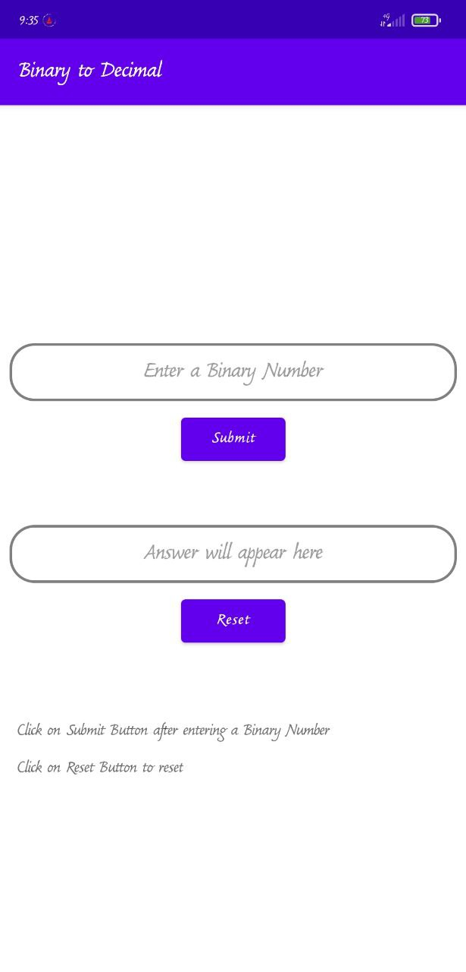

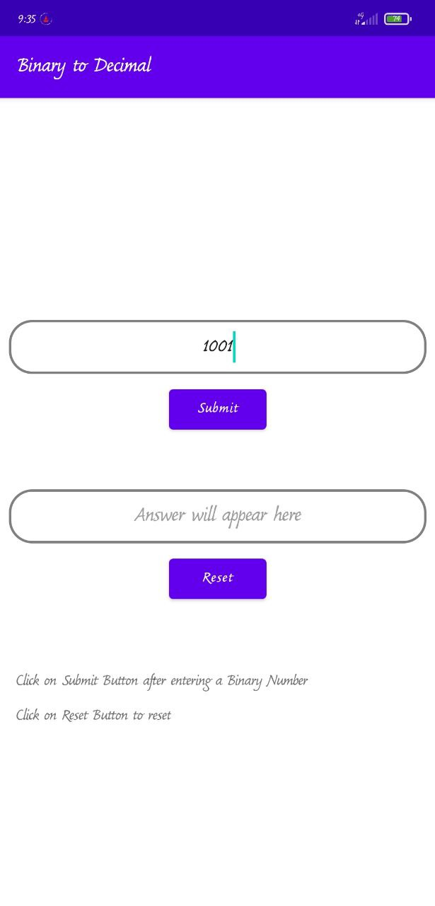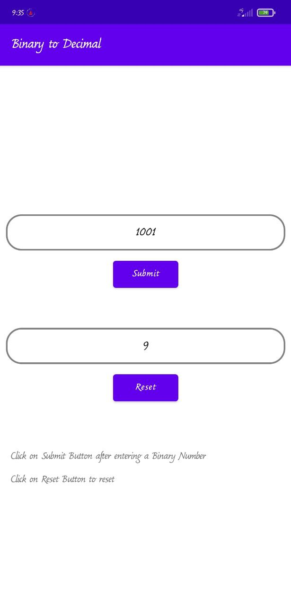

# CHAPTER 5

## CONCULSION

Implementing this application is very simple and useful to most of the people in the society. We hope that Binary to Decimal number converter stimulates others to pursue this goal.

Decimal data processing applications have grown exponentially in recent years thereby increasing the need to have hardware support for decimal arithmetic. Binary to BCD conversion forms the basic building block of decimal digit multipliers.

This in turn can be overcome by using a decimal Arithmetic and logic unit. The operations related to decimal arithmetic are typically slower, more complex and occupy more area and this leads to more power and less speed when implemented in hardware

This Application can be downloaded at:

<https://github.com/vinny2503/Binary-to-Decimal-Converter.git> where users can install and use the Application for simple binary to decimal conversions.

# CHAPTER 6

[www.geeksforgeeks.org](http://www.geeksforgeeks.org)

[www.javatpoint.com](http://www.javatpoint.com)

[www.Simplelearn.org](http://www.Simplelearn.org)

[www.github.com](http://www.github.com)

### BIBLIOGRAPHY